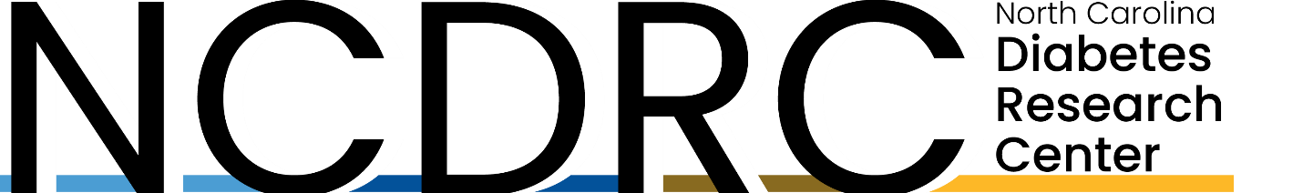

Mini Symposium
Theme: Obesity and Diabetes
Friday, January 26, 2024
Click Here to register!
1:00 pm - 1:05 pm | Human Studies Consultation Core Introduction – NCDRC Leadership  Donald A. McClain, MD, PhD  Professor, Department of Internal Medicine, Section of Endocrinology and Metabolism  Wake Forest University School of Medicine
1:05 pm - 1:50 pm | Speaker 1  “Functional Importance of Biased Agonism at the GLP-1R”  Jonathan Campbell, PhD  Associate Professor in Medicine  Associate Research Professor in Pharmacology and Cancer Biology  Member of Duke Molecular Physiology Institute  Duke University School of Medicine
1:50 pm – 1:55 pm | Break
1:55 pm – 2:40 pm | Speaker 2  “Incretins and the Brain”  Janice Hwang, MD, MHS  Chief, Division of Endocrinology and Metabolism  Associate Professor in Medicine  Associate Professor in Cell Biology and Physiology  UNC School of Medicine
2:40 pm - 2:55 pm | Q&A Session for both Speakers
2:55 pm – 3:00 pm | Closing Remarks – NORC Leadership  Ian Carroll, PhD  Assistant Professor, Department of Nutrition  UNC School of Medicine

